# Rossmoyne Senior High School

### Semester One Examination, 2015

### Question/Answer Booklet

If required by your examination administrator, please place your student identification label in this box

# MATHEMATICS 3A

## Section Two:

## Calculator-assumed

|  |  |  |  |  |  |  |  |  |
| --- | --- | --- | --- | --- | --- | --- | --- | --- |
| Student Number: In figures |  |  |  |  |  |  |  |  |

In words

Your name

## Time allowed for this section

Reading time before commencing work: ten minutes

Working time for this section: one hundred minutes

## Materials required/recommended for this section

##### *To be provided by the supervisor*

This Question/Answer Booklet

Formula Sheet (retained from Section One)

##### *To be provided by the candidate*

Standard items: pens (blue/black preferred), pencils (including coloured), sharpener,

correction fluid/tape, eraser, ruler, highlighters

Special items: drawing instruments, templates, notes on two unfolded sheets of A4 paper, and up to three calculators approved for use in the WACE examinations

## Important note to candidates

No other items may be taken into the examination room. It is **your** responsibility to ensure that you do not have any unauthorised notes or other items of a non-personal nature in the examination room. If you have any unauthorised material with you, hand it to the supervisor **before** reading any further.

## Structure of this paper

|  |  |  |  |  |  |
| --- | --- | --- | --- | --- | --- |
| Section | Number of questions available | Number of questions to be answered | Working time (minutes) | Marks available | Percentage of exam |
| Section One:  Calculator-free | 7 | 7 | 50 | 50 | 33⅓ |
| Section Two:  Calculator-assumed | 13 | 13 | 100 | 100 | 66⅔ |
|  | | | **Total** | 150 | 100 |

## Instructions to candidates

1. The rules for the conduct of Western Australian external examinations are detailed in the *Year 12 Information Handbook 2015*. Sitting this examination implies that you agree to abide by these rules.
2. Write your answers in this Question/Answer Booklet.
3. You must be careful to confine your response to the specific question asked and to follow any instructions that are specified to a particular question.
4. Spare pages are included at the end of this booklet. They can be used for planning your responses and/or as additional space if required to continue an answer.

* Planning: If you use the spare pages for planning, indicate this clearly at the top of the page.
* Continuing an answer: If you need to use the space to continue an answer, indicate in the original answer space where the answer is continued, i.e. give the page number. Fill in the number of the question that you are continuing to answer at the top of the page.

1. **Show all your working clearly**. Your working should be in sufficient detail to allow your answers to be checked readily and for marks to be awarded for reasoning. Incorrect answers given without supporting reasoning cannot be allocated any marks. For any question or part question worth more than two marks, valid working or justification is required to receive full marks. If you repeat any question, ensure that you cancel the answer you do not wish to have marked.
2. It is recommended that you **do not use pencil**, except in diagrams.
3. The Formula Sheet is **not** to be handed in with your Question/Answer Booklet.

Section Two: Calculator-assumed (100 Marks)

This section has**thirteen (****13)** questions. Answer **all** questions. Write your answers in the spaces provided.

Working time: 100 minutes.

Question 8 (7 marks)

The 137 bird sightings by members of a conservation group during a retreat were categorised on the basis of type and species as follows:

|  |  |  |  |  |  |
| --- | --- | --- | --- | --- | --- |
|  | Dove | Parrot | Seabird | Other | Total |
| Native |  | 21 | 24 |  | 73 |
| Introduced |  | 28 |  | 12 |  |
| Total |  |  | 33 | 27 | 137 |

(a) Complete the missing entries in the table above. (2 marks)

(b) What is the probability that a bird chosen at random from the sightings is

(i) a native seabird? (1 mark)

(ii) an introduced species that is not a seabird? (1 mark)

(iii) a native species or a parrot? (1 mark)

(iv) an introduced species, given that they are not a dove? (2 marks)

Question 9 (8 marks)

The histogram below shows the distribution of the number of consecutive sick days (as whole numbers) taken by employees at a workplace.

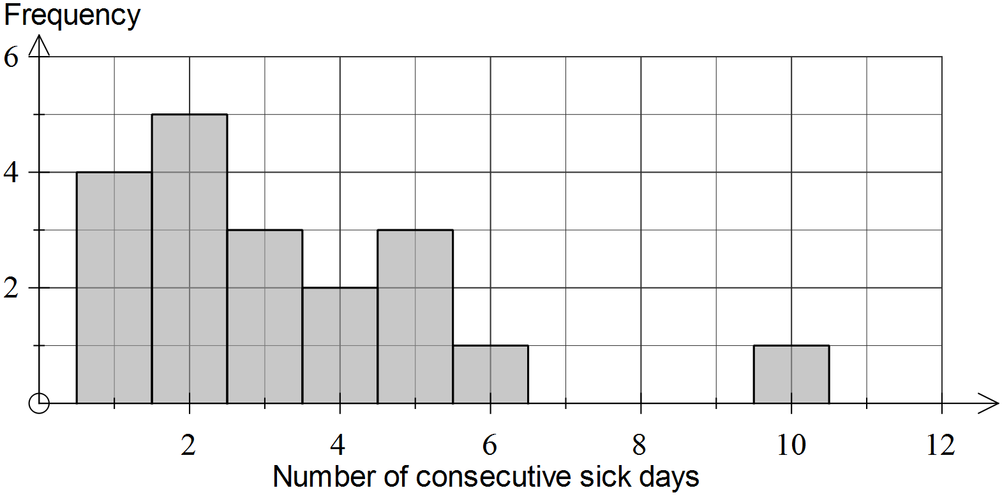

(a) Use information from the histogram to complete the table below. (1 mark)

|  |  |  |  |  |  |  |  |
| --- | --- | --- | --- | --- | --- | --- | --- |
| Consecutive sick days | 1 | 2 | 3 | 4 |  |  |  |
| Frequency | 4 | 5 |  |  |  |  |  |

(b) Determine the mean and standard deviation of the number of sick days. (2 marks)

(c) Construct a boxplot for the data shown in the histogram on the scale below. (2 marks)

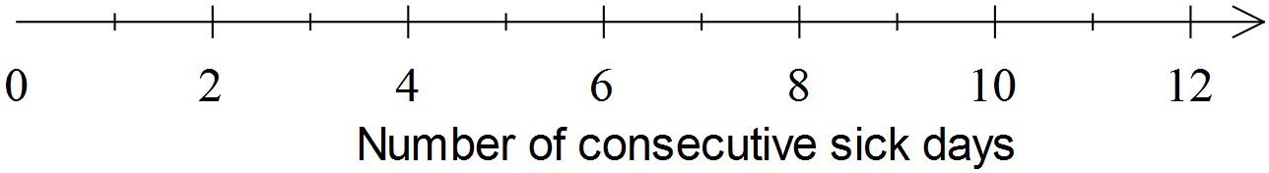

(d) Use a calculation to determine whether or not the dataset contains an outlier. (2 marks)

(e) Explain one advantage of displaying data as a histogram rather than as a boxplot.

(1 mark)

Question 10 (6 marks)

(a) The variable  is directly proportional to the variable . Describe the effect on  if  is doubled. (1 mark)

(b) The variable  is related to the variable  by the equation .

(i) Calculate  when . (1 mark)

(ii) Describe how  varies as  changes. (1 mark)

(iii) Sketch the relationship between  and , adding suitable scales to the axes below. (3 marks)

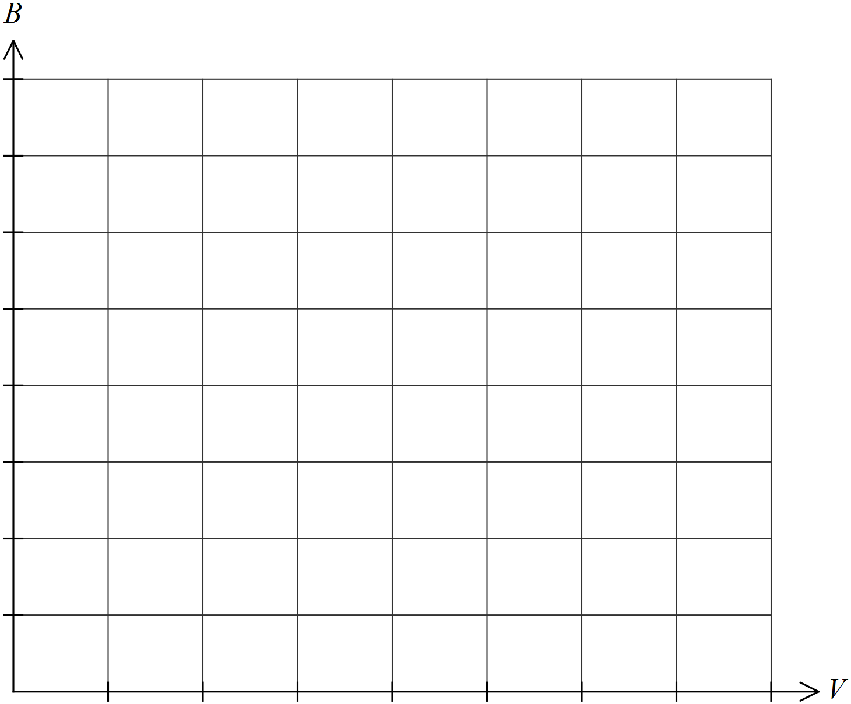

Question 11 (8 marks)

The weights of tomatoes sold by a market gardener were observed to be normally distributed with a mean of 84 g and a standard deviation of 12 g.

(a) What proportion of tomatoes will weigh less than 60 g? Give your answer to three significant figures. (2 marks)

(b) What is the probability that a randomly selected tomato will weigh between 70 and 100 g?

(1 mark)

(c) Above what weight will the heaviest 5% of tomatoes fall? (2 marks)

(d) Premium tomatoes, those with a weight between 80 and 90 g, can be sold for more than other tomatoes. Estimate the number of premium tomatoes that would be found in a box of 288 randomly packed tomatoes. (3 marks)

Question 12 (8 marks)

(a) The graph of  is shown below.

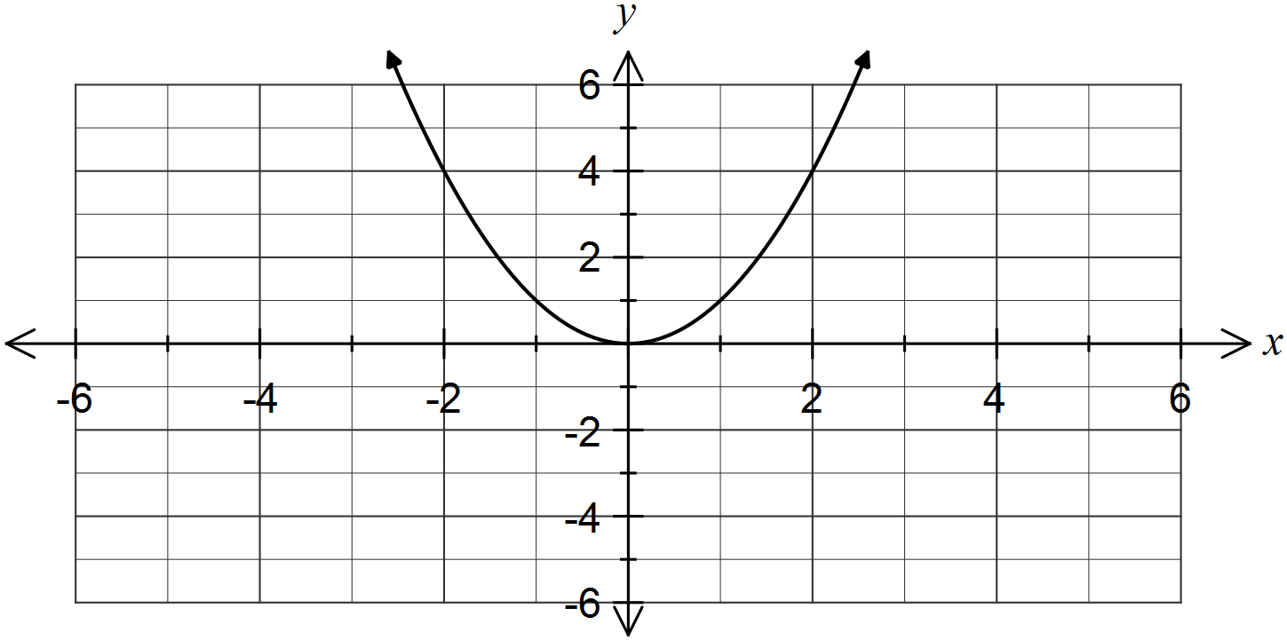

(i) On the axes above, sketch the graph of . (2 marks)

(ii)  can be written in the form . Determine the values of  and .

(2 marks)

(b) On the axes below, sketch the graph of . (2 marks)

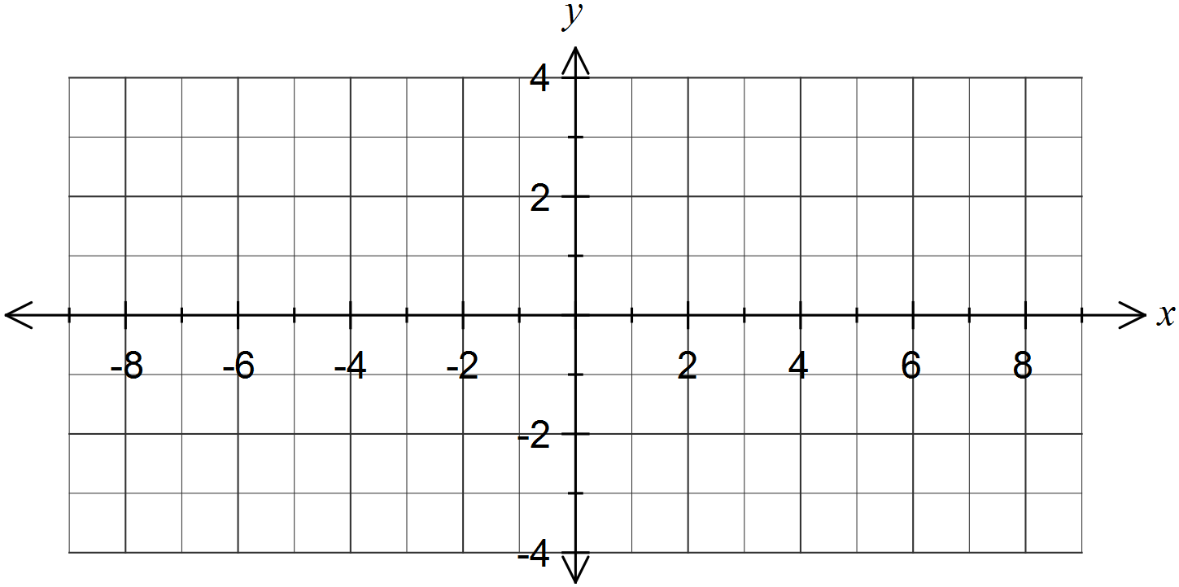

(c) Describe how to use the graph in (b) to obtain the graph of . (2 marks)

Question 13 (8 marks)

A young person has just started work and borrowed $7 500 to purchase a car. They can afford to make monthly repayments of $660. Interest on the loan is charged monthly.

The spreadsheet below shows the balance and interest of the loan for the first three months.

|  |  |  |
| --- | --- | --- |
| Month | Balance at start of month ($) | Interest for month ($) |
| 1 | 7 500.00 | 52.50 |
| 2 | 6 892.50 | 48.25 |
| 3 | 6 280.75 | 43.97 |

(a) Use information from the table to show that the annual interest rate on the loan is 8.4% per annum. (2 marks)

(b) Determine the balance at the start of month 4, and the interest for this month. (2 marks)

(c) Write a recursive rule to determine the balance at the start of each month. (2 marks)

(d) The loan is fully repaid by the end of month 12. Determine, to the nearest dollar,

(i) the amount of the final repayment. (1 mark)

(ii) the total amount of interest on the loan. (1 mark)

Question 14 (8 marks)

The median boxplot represents the set of scores .The scores are all integers and are listed in ascending order.

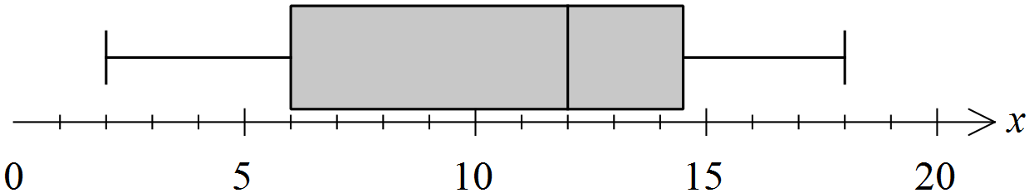

(a) Evaluate . (4 marks)

(b) When a tenth integer is added to the original nine scores, the boxplot changes as shown below. Determine the value of the new score. (2 marks)

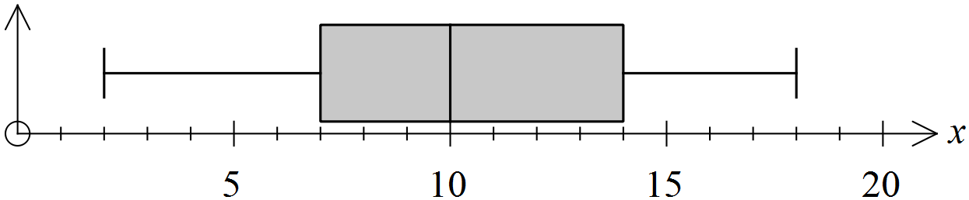

(c) When one integer is removed from the original set of nine scores, the boxplot changes as shown below. Determine the value of the score that has been removed. (2 marks)

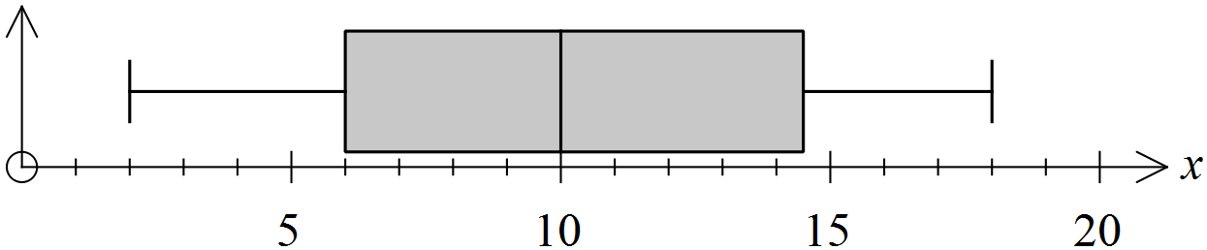

Question 15 (11 marks)

(a) The function  is defined by .

(i) Determine the range of  over the domain . (2 marks)

(ii) Determine the transformations required to obtain the graph of  from the graph of . (2 marks)

(b) The function  is defined by . Determine the domain and range of .

(2 marks)

(c) The graph of the function  is shown below.

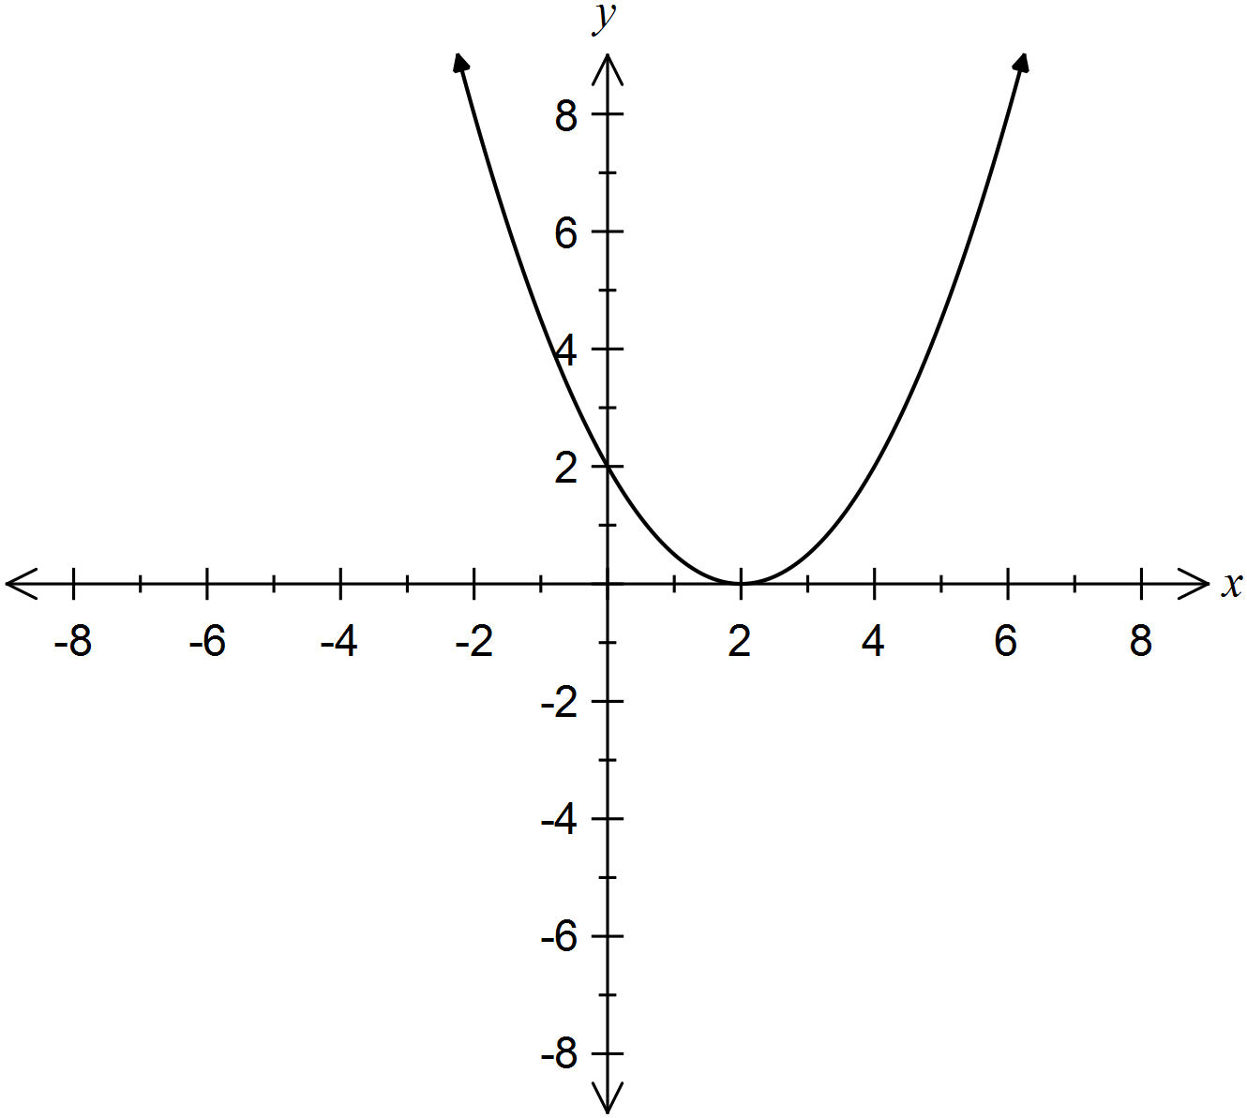

(i) Determine the values of ,  and . (3 marks)

(ii) On the axes above sketch the function . (2 marks)

Question 16 (7 marks)

(a) A student achieved a final semester mark of 70% in his course. This mark was calculated from his weighted marks in the three areas of the course as shown in the table below.

|  |  |  |  |
| --- | --- | --- | --- |
|  | Lab skills | Theory | Practical |
| Mean score (%) | 69 | 75 |  |
| Weighting (%) | 25 | 40 | 35 |

Determine the missing mean score in the table for his practical work. (3 marks)

(b) Part of the practical assessment carried out by the student was to estimate the size of a population of wild rabbits in a nature reserve. Together with some fellow students, 35 rabbits were captured, tagged and released in the reserve. A few days later and at the same place, 42 rabbits were caught and it was noted that just three of these were tagged.

(i) Show how the student could use these figures to estimate the size of a population of wild rabbits in a nature reserve. (2 marks)

(ii) The students' supervisor was concerned that the tag on one of the rabbits recaptured had not been placed by this group of students, but by another group. The student assumed that removing this rabbit from their calculations wouldn't change their estimate by much and did not recalculate the population estimate. Comment on this assumption. (2 marks)

Question 17 (7 marks)

Consider a country in which mobile telephone numbers always start with the two digits 06 followed by eight other digits. An example of such a number is 0624 654 321.

(a) Determine the number of possible mobile telephone numbers if

(i) there are no other restrictions.

(1 mark)

(ii) the first four digits must be 0624 and no digits are repeated in the number. (1 mark)

(iii) only even digits can be used, with no two adjacent digits the same. (1 mark)

(b) A caller starts a number with 0624 and then randomly choses digits for the rest of the number. Determine the probability that the number dialled

(i) ends in 5. (1 mark)

(ii) contains a 6. (1 mark)

(iii) does not contain an 8, given that it only contains even digits. (2 marks)

Question 18 (7 marks)

Towns P and Q are 45 km apart and connected by a road passing through flat countryside.

At noon, a cyclist A leaves town P and cycles at a constant 15 km per hour towards town Q.

Twenty minutes later, cyclist B leaves town Q and cycles at a constant speed towards town P, stopping at 2 pm for a 30 minute rest before continuing at the same speed. Part of their journey has been shown on the graph below.

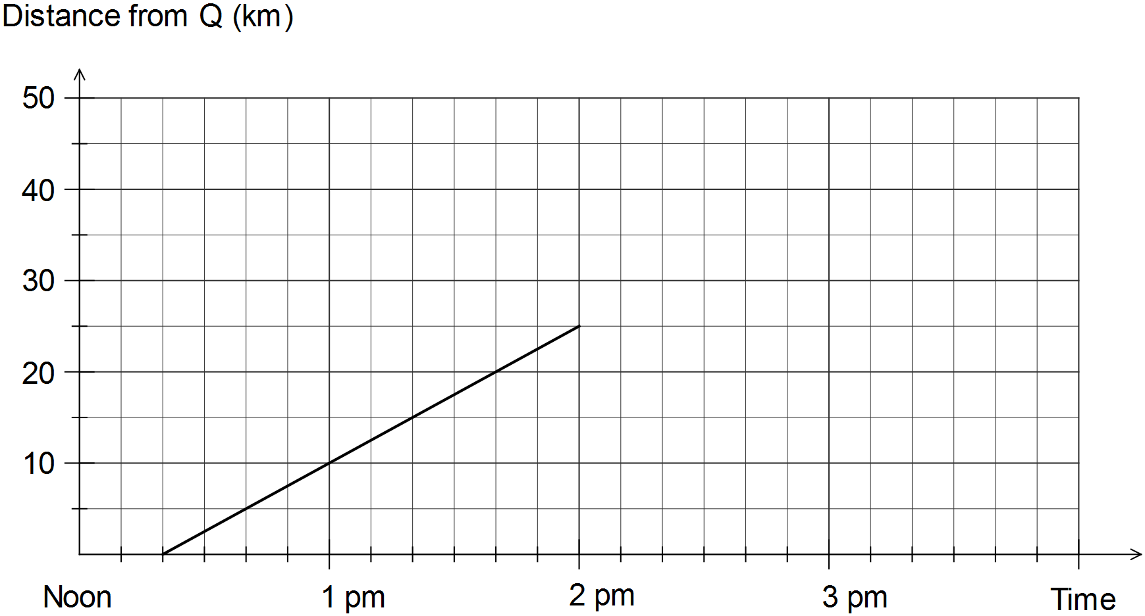

(a) Use the graph above to determine the speed of cyclist B between 12:20 pm and 2 pm.

(1 mark)

(b) Complete the travel graph for cyclist B between 2 pm and 3 pm. (2 marks)

(c) Draw the travel graph for cyclist A from noon until 3 pm. (1 mark)

(d) At what time do the cyclists pass each other? (1 mark)

(e) A motorist going to town Q left town P at 1:45 pm and passed cyclist B just as the cyclist began their rest. Determine the average speed that the motorist was travelling at.

(2 marks)

Question 19 (8 marks)

Water is to be drained from a tank. In the first second after the tap is opened, 10 L drains out. During the next second, 9.5 L drains and so on, so that in each subsequent second 5% less water drains than in the previous second.

(a) The situation can be represented by a recursive rule of the form . State the values of . (2 marks)

(b) How many litres of water will drain from the tank during the tenth second? Give your answer to one decimal place. (2 marks)

(c) How many litres of water will drain from the tank during the first sixteen seconds?

(2 marks)

(d) If the tank initially held 170 L of water, determine how long it takes to completely empty and state how much water drains in the final second. (2 marks)

Question 20 (7 marks)

(a) Two points,  and  are shown below on a unit circle.

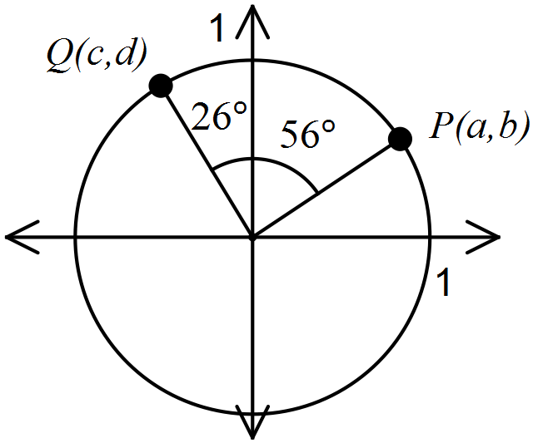

Determine each of the following in terms of .

(i) cos 64°. (2 marks)

(ii) sin 146°. (2 marks)

(b) A parallelogram has sides of 25 and 30 cm and an area of 700 cm2.

(i) Sketch a diagram to represent this information. (1 mark)

(ii) Use trigonometry to determine the length of the longest diagonal of the parallelogram, giving your answer to three significant figures. (2 marks)

Additional working space

Question number: _________

Additional working space

Question number: _________

Additional working space

Question number: _________

This examination paper may be freely copied, or communicated on an intranet, for non-commercial purposes within educational institutes that have purchased the paper from WA Examination Papers provided that WA Examination Papers is acknowledged as the copyright owner. Teachers within Rossmoyne Senior High School may change the paper provided that WA Examination Paper's moral rights are not infringed.

Copying or communication for any other purposes can only be done within the terms of the Copyright Act or with prior written permission of WA Examination papers.

*Published by WA Examination Papers*

*PO Box 445 Claremont WA 6910*